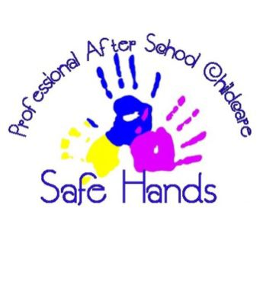
Key Person Policy
Safe Hands after School Club

At safe hands after school club we want children to feel safe, stimulated and happy in their setting and to feel secure and comfortable with the staff. We also want parents to have confidence in both their children’s well-being and their role as active partners with the setting.
We aim to make the setting a welcoming place where children settle quickly and easily because consideration has been given to the individual needs and circumstances of children and their families. This is given to the child prior to starting with a sheet called ‘all about me’ so we can find out their likes, dislikes and interests.
We believe it’s important that all our staff is familiar with all the children and their families – this is where we take our credit of a ‘family feel’ ethos. Every staff member at safe hands are committed to all our children we care for and are able to provide secure relationships.
Children that are currently in our care and are at the age of EYFS (key stage 1) will be assigned a key person. This key person will make it their priority to ensure that the child feels safe, secure and happy at all times in their setting; and that their parents/carers also feel happy.
The key person role is set out in each setting and is a welfare requirement of the early year’s foundation stage.
Procedures:
- A child is allocated a key person before they start the setting.
- The key person is reasonable for settling the child into our setting.
- The key person is reasonable for handing over and sharing any information to the parent/carers about any accident or incident forms that have occurred and may need signatures for.

Policy written by: Ellis Worthy | Date: September 2023
Policy to be reviewed: September 2024 | Signed: Mel Lawlee

