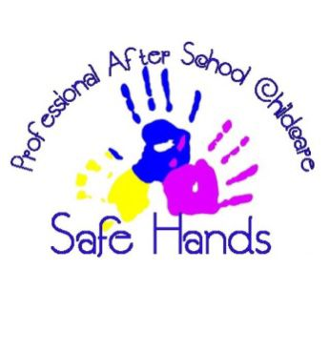
Manual Handling Policy
Safe Hands after School Club

Manual handling is one of the major causes of absence through injury in the workplace. At Safe Hands after School Club we work with our staff, provide training, and undertake risk assessments in order to eliminate hazardous manual handling activities as far as possible. This policy is written with reference to the Health and Safety at Work Act 1974, which places a duty on employers “to ensure so far as is reasonably practicable, the health, safety and welfare of its employees” and to the Manual Handling Operations Regulations 1992 (as amended).
Procedure:
In order to limit the risk of injury from manual handling operations, Safe Hands will:
• Eliminate hazardous manual handling activities, as far as is reasonably practicable
• Assess the risks associated with any manual handling activities that cannot be avoided. The purpose of the risk assessment is to reduce the risk of injury to the lowest possible levels, and should consider:
• The task
• The load
• The individual undertaking the task
• The working environment
The main manual handling hazard at Safe Hands after School Club is likely to be the setting-up and clearing away of equipment. This is unavoidable, but staff should carry out the operation with reference to the guidance given in the manual handling training that we provide. It may be necessary to seek the assistance of an additional member of staff in order to minimise the risk of injury, for example when carrying tables and other heavy or bulky items.

Employee’s duties
It is the responsibility of all staff at Safe Hands to:
• Comply with any instructions provided in safe manual handling techniques
• Not put their own health and safety or that of others at risk by carrying out unsafe manual handling activities
• Report to the Manager any problems which may affect their ability to undertake manual handling activities, including physical and medical conditions (e.g. pregnancy, back problems).
In summary
Avoid: Whenever possible, avoid manual handling situations.
Assess: If avoidance is not possible, make a proper assessment of the hazard and risks.
Reduce: Reduce the risk of injury by defining and implementing a safe system of work.

This policy was adopted by: Mel Lawlee | Signed: Mel Lawlee
To be reviewed: September 2024 | Date: September 2023

Written in accordance with the Statutory Framework for the Early Years Foundation Stage (2017): Safeguarding and Welfare Requirements: Staff Qualifications, training, support and skills [3.20]

