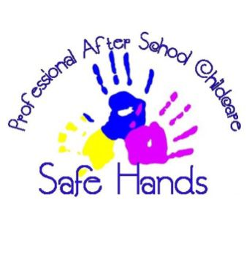
Confidentiality Policy
Safe Hands after School Club

At safe hands after school club we take the role of confidentiality very seriously. Safe hands are an organisation that processes personal data and are subjected to the General Data Protection Regulation (GDPR) and the Data Protection Act 2018. In order to respect the dignity of all users, the club will actively promote confidentiality in the fowling ways:
- Ask for consent to share information with teachers and other professionals
- Consider safeguarding when sharing information
- Be aware of the information you have and whether it is confidential
- Keep records whenever confidential information is shared
- Be up to date with the laws and rules surrounding confidentiality
- Providing guidelines to support staff when record keeping
- Providing safe secure places to keep records
- Providing parental/carers access to their child’s own records
Policy written by: Ellis Worthy | Policy checked by: Mel Lawlee
Policy written on: October 2nd 2023 | Renewal date: October 2024

