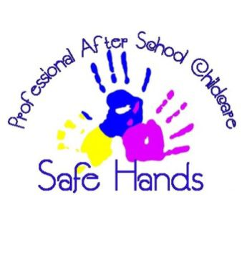
Staff Recruitment Policy
Safe Hands after School Club

Safe hands was created by a working mother called Melanie Lawlee. The company has since expanded and we are now running at two settings. Safe hands remain with the ethos ‘safe hands family’ this is central to all we do. We are so proud to have an amazing team working together to provide the best childcare to the local area.
We take recruitment very seriously, ensuring that only the highest childcare providers work at our setting. We ensure that;
- All applicants for staff and volunteer positons will be treated equally and fairly.
- Ethnic backgrounds, languages cultures and faiths are celebrated.
- All must are subjected to a full DBS check.
- Before starting a role all staff must undertake food and hygiene, health and safety, child protection, prevent and FGM training.
- A full induction meeting will take place with managers before starting.
- All staff must be available for regular staff meetings as well as one to one supervisions.
- All staff must be prepared to undertake training towards professional qualifications to their relevant role.
- All job posts are subject to a six monthly probationary period.
- Staff and volunteers will be selected with a range of qualifications, skills and experiences relevant to the clubs objectives and aims.

Policy written: September 2023
Policy written by: Ellis Worthy
Policy due to be updated: September 2024

